WSDOT Unit and Integration Testing Strategy

Background
The current state of our testing process is weak at best. We currently have no automated way to do any testing, unit or otherwise. This is not a good thing, especially since we are writing engineering software which can directly affect public safety.
The purpose of this document is to determine the minimum requirements for a unit and library-level testing system and to develop and document a practical testing process.
Application-level and acceptance testing is related to this, but is an entirely different can of worms. We will have to deal with that eventually, but not here.

Unit and Package-Level Testing Requirements

Lean and Mean
We don’t have a lot of time and money to spend on testing, so whatever we do has to be automated and as efficient as possible without sacrificing quality.

Test Release and Debug Builds
Testing must support both Debug and Release builds. At this time, we have elected not to compile unit test code out of release builds, but we must take care so that we may do this at a later date.

Separate White-Box and Black-Box Testing
According to testing experts it is important to make this distinction although the full reason for this is not clear. One known reason is to test that class methods have correct access levels. We should probably just listen to the experts on this and not get burned later.

During white box testing, you are allowed to use your knowledge of the class’s implementation to design tests. You can call methods out of order and you can pass weird values to methods to make sure they handle them properly. One example of a white box test is to pass in a bad number to make sure the PRECONDITION works. You can’t do this with black box testing.

During black box testing, you must restrict your knowledge of the class to its public/protected interface. Tests cannot assume anything about the class’s implementation.

Tests Must Not Be Lost
It is very important that time spend developing test code is not wasted by losing control of the test code. Our current testing strategy of adding a TestMe() function to all classes forces developers to fix broken testing code and “glues” the test code to the classes. This is a good thing and should not be given up.

Test Reporting
It must be easy to spot and locate a test failure when running a test script. We cannot have a testing process where it takes an hour to figure out which class caused the entire test script to fail. A little time spend up front getting this right will pay for many hours of frustration down the road. A message like “Test failed on Line 233 of myClass.cpp in Package myModule” would be appropriate. Failures should be reported in a test summary report upon completion of the script.

Test Completion
If a single class test fails during a run of a test script, it should not terminate the entire test. This includes possible uncaught exceptions coming out of the test routines?

Code Coverage
Ideally, the unit tests should cover every line of code in every class. Given our lack of testing resources (including lack of a coverage analysis tool), this may not be practical. However, developers should design tests so that all branches “significant” code is covered. The profiler that comes with Visual C++ may be of some help here.

Build Test (Unit and Integration Level)
Testing should also show that builds are not broken by addition of new code and tests.

Tests Should Not Add Excessive Dependencies to Packages
When designing class-level tests, effort should be made to avoid adding dependencies to that class for the sole purpose of testing.

Black box testing has the highest potential for creating dependencies. If the goal of a black box test is to test a collection of classes working together, then it probably shouldn’t be part of a class level TestMe

Error Handling
The testing process should also include testing of error handlers. I know, this is a real PINTA, but it must be done to insure a reliable system.

Integration Testing
Whenever a new class or package is added to a library, there should be a well defined process and a checklist for insuring that the component has been properly unit tested and will integrate with existing code.

Inheritance
It is a common myth that once a base class is tested that it need not be retested by its siblings. This is plain wrong. All methods accessible in the inheritance hierarchy must be tested. A class level TestMe only needs to provide tests for the methods it adds to the class and the virtual methods it overrides. The class level TestMe must call TestMe for its parent class.

GUI classes
There is no doubt that GUI classes should be testing. However, we do not have a visual testing tool, so this cannot be automated.

Persistence
Recent experience has shown that persistence is invaluable for testing of complex components, and especially components which are aggregates. A uniform strategy for making classes persistent should be formulated. ASCII text-based persistence is much for useful for testing purposes than binary-based persistence.

A Proposed Solution
This section describes a testing plan and process that nearly meets the requirements given above. A directory structure for the proposed scheme is given in Figure 1.
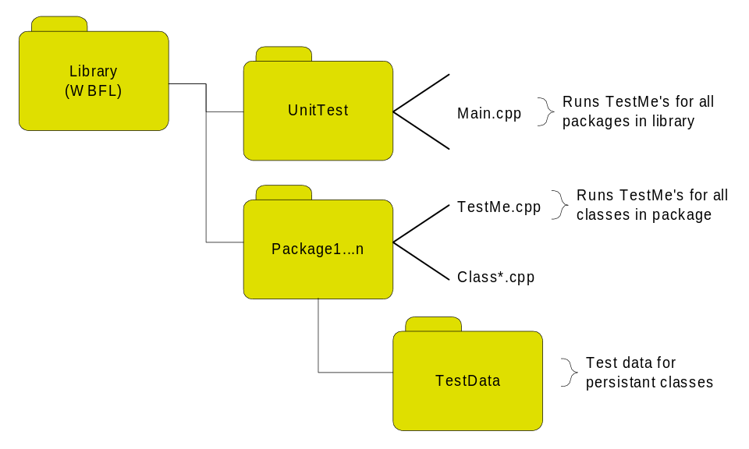
Figure 1
Directory Structure for Testing Plan

TestMe() - For Classes
All classes containing concrete methods should have a public unit-testing function with the following signature:

bool TestMe(dbgLog& rLog);

This function should return true if the test completes successfully. This method must be a static member of the class.

Black and White
The TestMe() function should provide both black-box and white-box testing of the class. Since TestMe() is a member function of the class, it cannot be directly used to perform “correct” black box testing. Instead, all black box tests should be relegated to a file-scope free function which is declared and defined within the .cpp file for the class. TestMe() can then call this function to perform black box tests.

Coverage
Again, we do not have access to a code coverage tool (and besides using one sounds like a lot of time and effort anyway). Hence, it is the duty of the programmer to design black and white box tests which exercise complete coverage of all code in the class. Consideration should also be given to testing of error conditions.

TestMe Internals
TestMe() should take advantage of the ostream in the test logging object and write out state information frequently. At the very least, TestMe() should write out “Entering TestMe for Class …” at the top and “Exiting TestMe for Class …” at the end.

This is easily accomplished by using the TESTME_PROLOGUE and TESTME_EPILOG macros in the first and last lines of the TestMe method

Test Logging Class
The test logging class, dbgLog can be found in the WBFL\Include\System directory.

The public interface of dbgLog is as follows:

class dbgLog
{
public:
// used by TestMe()
ostream& os;
void AddEntryToLog(std::string error message, bool IsError);
dbgDumpContext& DumpCtx(); // Returns a dump context that causes a class’s Dump method to writing into os.

// used by test client
Int32 GetNumEntries() const;
Int32 GetNumErrors() const;
void DumpErrorsInLog(std::ostream& os);
void DumpEntireLog(std::ostream& os);}

TestMe functions can dump run-time information into the error log using the DumpCtx method to obtain a suitable dump context object. . This is not necessarily error information, but also status information about the test and state information about the test that may be helpful for debugging.

TestMe functions should begin with the macro TESTME_PROLOGUE and end with the macro TESTME_EPILOGUE. These macros assure the correct local variables are setup, cleaned up, and returned by the function.

The AddEntryToLog() function registers the outcome of a test with the testing system. This function normally should not be called directly, but is called through the TEST_FAIL, TEST_PASSED, and TRY_TEST macros.

For each of the macros listed below, the X version is used to record an more descriptive message

TEST_FAIL and TEST_FAILX automatically adds class name and line number error information to the log. It also maintains the status of a local bool variable within TestMe() so that TESTME_EPILOGUE can return the correct error status.

TEST_PASS and TEST_PASSX is used to record information about the number of tests which were run.

TRY_TEST takes a Boolean expression. Use this macro as a shortcut rather than calling TEST_PASS or TEST_FAIL for a simple test expression. The Signature of TRY_TEST is:

TRY_TEST(bool)
TRY_TESTX(bool,msg)

If the bool is false, the test passes and TEST_PASS is called, if true, the test failed and TEST_FAIL is called.

TestMe() for Packages
Each package should have a file called UnitTest.cpp in its source directory and header file named UnitTest.h in its include directory. These files will declare and define a class called pkgUnitTest(), where “pkg” is the package prefix for the given package. pkgUnittest will have a single static function called TestMe(). It is the job of TestMe() to call all of the TestMe()’s for all classes contained in the package, and optionally, run other testing routines that may be defined for the package. The function signature for pkgUnitTest::TestMe() is identical to the class-level TestMe().

Testing for DLL’s
Each DLL should have an exported method called UnitTest that takes a dbgLog as an argument. UnitTest should call pkgUnitTest::TestMe() for each package implemented in the DLL. For big libraries like WBFL, there should be one console app that does a GetProdAddress for every DLL’s UnitTest method and runs the unit tests for all DLLs in the library. This provides an easy method for testing a whole bunch of DLL’s at once.

Build To Test
Each library (eg, WBFL) should have a project called UnitTest located directly below the main library directory. The purpose of this project is twofold: 1) to maintain package dependencies and properly build Release and Debug versions of all packages contained in the library, and 2) to build (and optionally run?) a console application for unit testing the packages.
The build-to-test strategy will also have other positive side-effects. It will create a single, unified builder for the library and it will insure that no undefined symbols exist within the library.

Library Unit Testing Application
Each library should have a single test program contained in the UnitTest directory. If desired, this program can be easily incorporated in the daily build and smoke test for a given application.
The library test unit testing application should report the status of the test completion and pipe all dump information to a file specified on the command line. The final status information from the test should also be appended to the dump file. The application can use information from the TestLogger to print out information about failed tests.
The application should terminate using exit(0) for a successful test and exit(1) for an unsuccessful test. This will aid in the batch automation of testing multiple libraries.

Dumping
Each class in the library should have a Dump function. The signature of the function is:

void Dump(dbgDumpContext& dmp);

This function should dump out all member variables and state information for the class and its parent classes. The dbgDumpContext class has a public ostream& called os that is used to pipe dump information into. As with all member functions, the Dump() function should be called at least once from TestMe().

#define Macros
At first, it seemed natural to use the C preprocessor to compile out TestMe() and Dump() for Release builds. But, in reality, testing has little to do with Debug and Release builds. In fact the peskiest bugs typically occur in Release builds, so we need all the help we can get to find them.
The TestMe() and Dump() functions should be guarded by a macro called UNIT_TEST. This will allow for unit testing in all build configurations.

Unresolved Issues
- Persistence.
- Application/Acceptance Testing.
- GUI testing.
- Testing of exceptions and error handling

Integration Testing Check List
The following check list should be used when adding new classes, routines or packages to a library.

Item | Description | Done?
class TestMe() | Was a TestMe() function written for the class?
Coverage | Were steps taken to insure that the TestMe covers all lines of code in the class?
Error Handlers | Was code written to test error handlers?
Dump | Did you call Dump() at least once from TestMe?
Persistence | If this class will be aggregated into other classes, did you implement class persistence?
Inheritance | Did you call all member functions of the class including inherited functions?
Release | Did you test both Debug and Release Configurations?
UNIT_TEST | Did you turn off the UNIT_TEST macro and insure that all code builds without it?
Source Control | Are you absolutely sure that all routines are in source control and have been checked in?
CodeWiz | Does this new file or package affect CodeWiz in any way?
Package TestMe() | Did you update the package TestMe function to account for the new class?
Test Application | If you added a new package, did you add a call to the package TestMe?
Settings | Did you make sure that the build settings are set per the WSDOT C++ Programmer’s Guide (TBD)?
Build | Does the Test Application build the new package?
Test | Did you run a clean get and build for both Debug and Release after code integration?
Smoke | Did you check the results of the daily smoke and build test to make sure that you didn’t cause any problems?
Source code walk-through

- The main.cpp file for the WBFL automated system test should use a table of dll names and a loop for testing each DLL in the table, rather than

// system library
std::string libname = "c:\\library\\sys10d.dll";
st = TestDll(libname, tl);

// geometric primatives
libname = "c:\\library\\Geom10d.dll";
st = TestDll(libname, tl);

- The UnitTest app should log an error if a dll is not found
- The UnitTest app should log an error if a dll does not support the std entry point
- The TEST_PROLOGUE macro should take the class name as an argument so it can report “Beginning test for pkgMyClass”
- The TEST_EPILOG macro should take the class name as an argument so it can report “End of test for pkgMyClass”
- Whitespace and/or separator lines are need between the testing of each class, package, and dll to make the test log more readable.
- Change test.out to UnitTest.log
- Should the test log have a time stamp?
- In UnitTest.cpp, why is the #include<iostream> used?
- Will UnitTest.cpp compile if UNIT_TEST is not defined?
- Change the name of dbgTestLogger to dbgLog
- dbgLog should have a DumpCtx() method that returns a reference to a dbgDumpContext object that will write its data into dbgLog’s ostream.
- TEST_PASS/TEST_FAIL macros... Can the ostringstream be declared as a local variable for the method rather than in each macro? Could be declared by TEST_PROLOGUE
- TEST_PASS/TEST_FAIL need extended version to let code writer provided a descriptive message
- TRY_TEST should stringize pf and write it to the log
- TRY_TEST needs an extended version.
- Class level TestMe... CodeWiz generated code should look like this
bool pkgMyClass:TestMe(dbgLog& rLog)
{
TEST_PROLOGUE(pkgMyClass);
#pragma Reminder(“Implement unit tests”)
TEST_FAILEDX(“Tests not implemented”);
TEST_EPILOG(pkgMyClass);
}
- The dbgDumpContext stuff isn’t implemented

